**Creating a Lambda Function and Testing Manually**

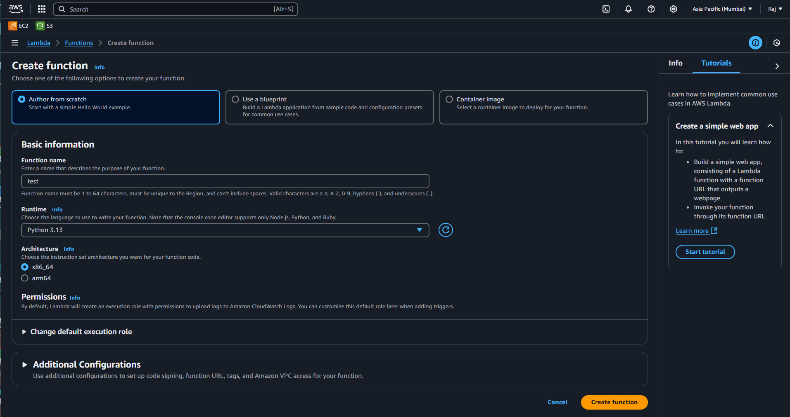

Go to Lambda and Select create a function and type the basic Information and select the Runtime(programming language) you want your lambda function to run on

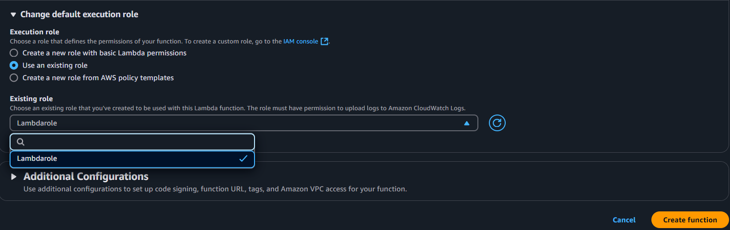

Select use an exisiting rolee and select the I AM role

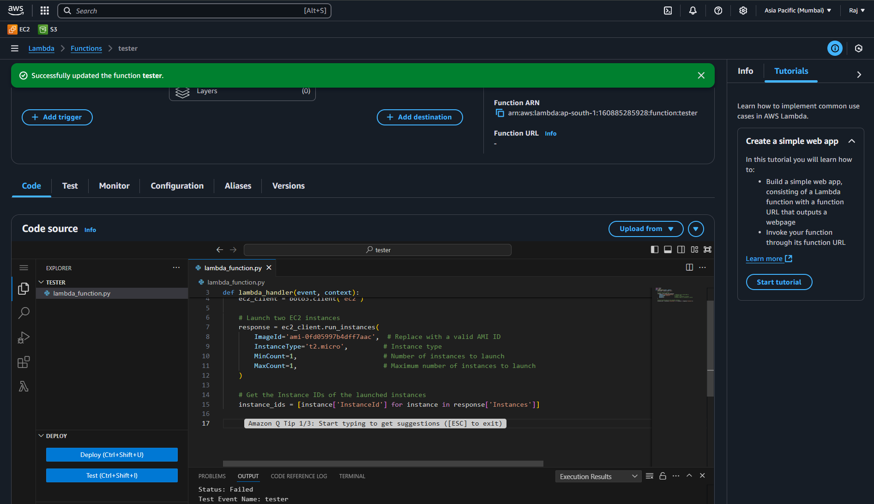

Typed a code to launch an Instance in Lambda Code panel

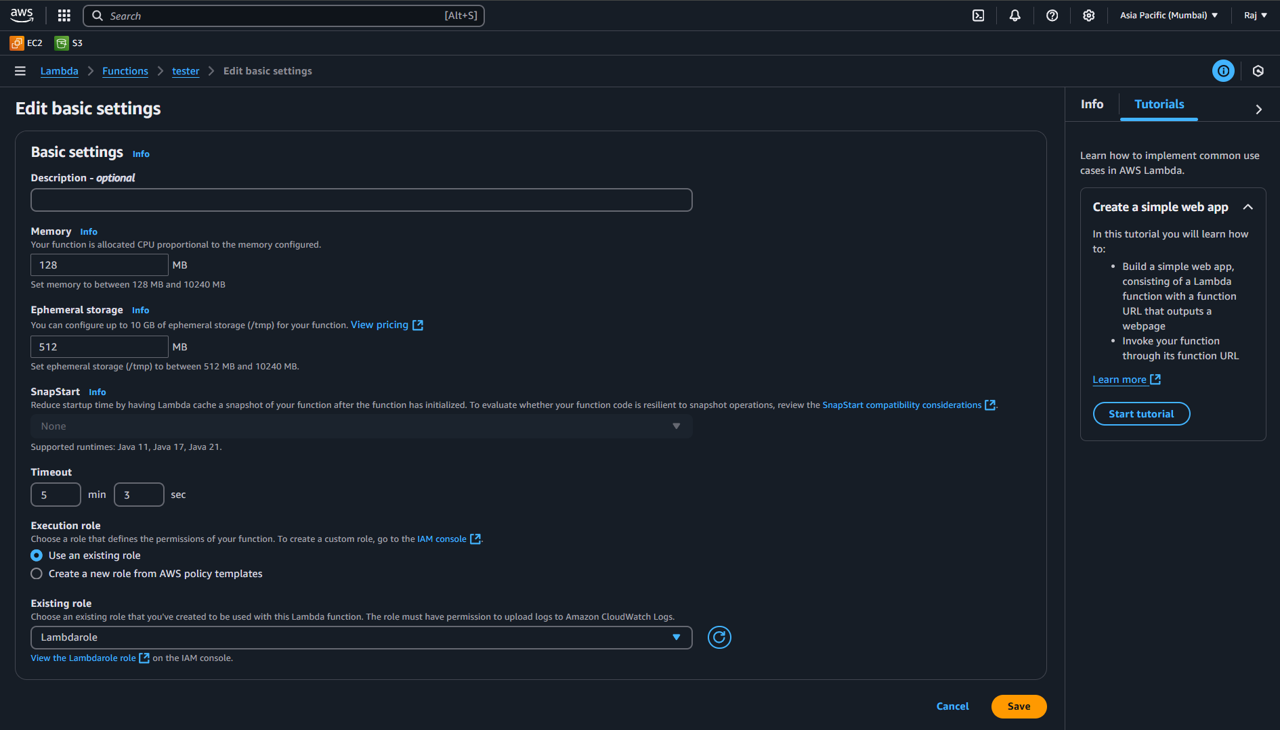

Configured the time-out(run-time) for Lambda Function tester

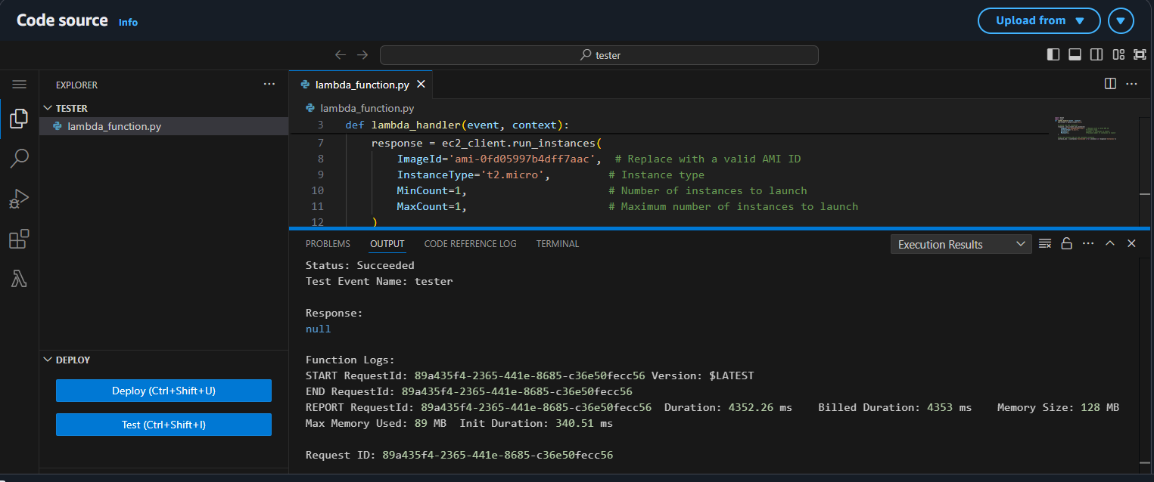

Program executed and Instance Launched

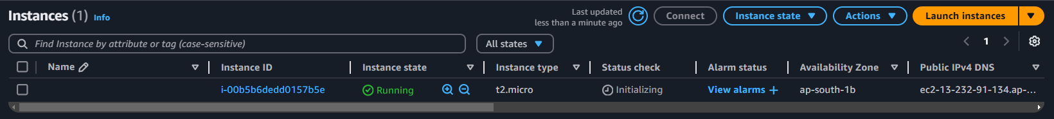

Instance launched

**Adding Triggers and Destination to the Lambda Function and Executing**

**Adding Trigger :-**

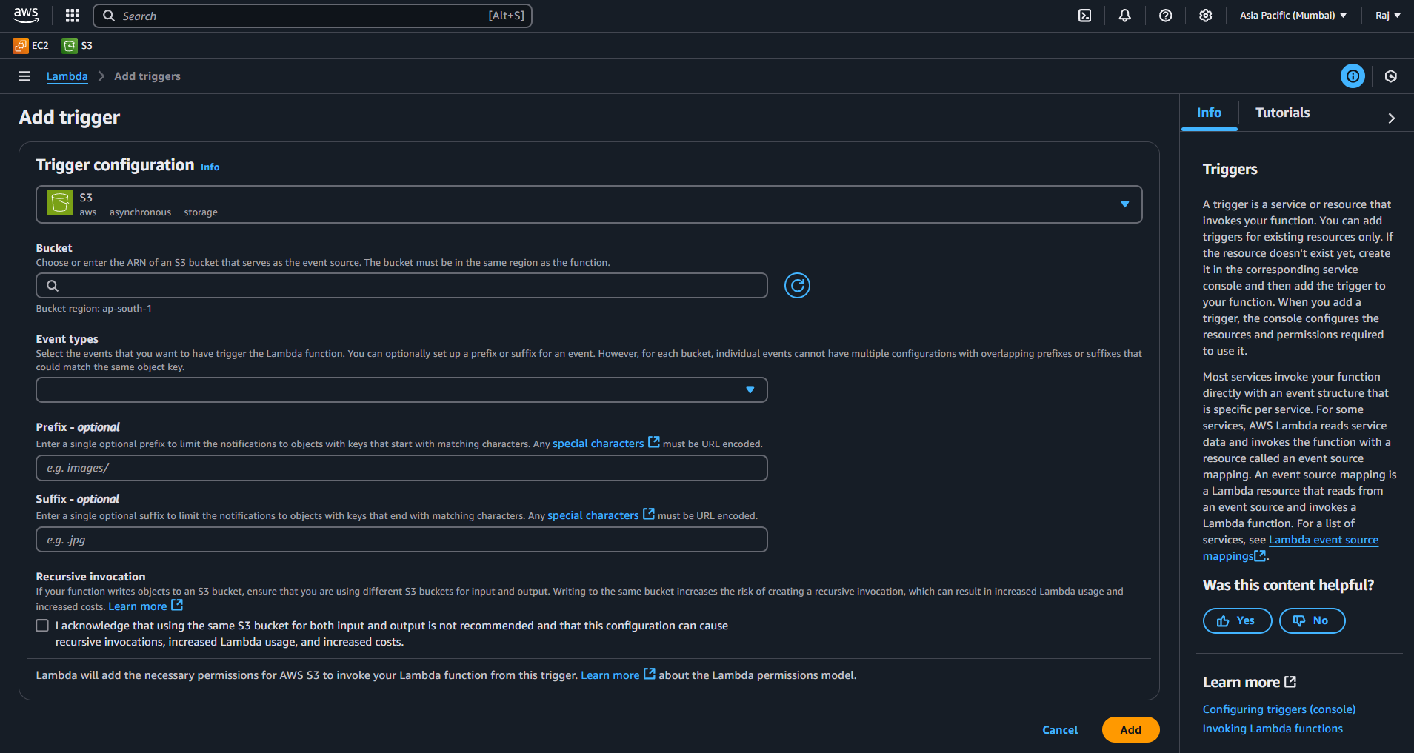

Select Add Trigger and Add Configuration

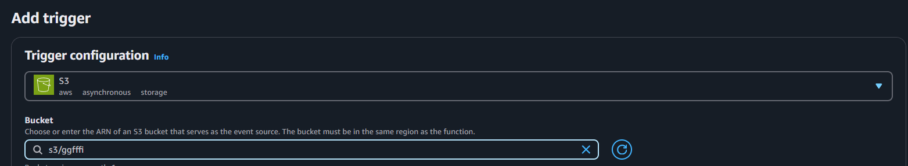

Selected the Trigger as S3 Bucket and Added the Bucket

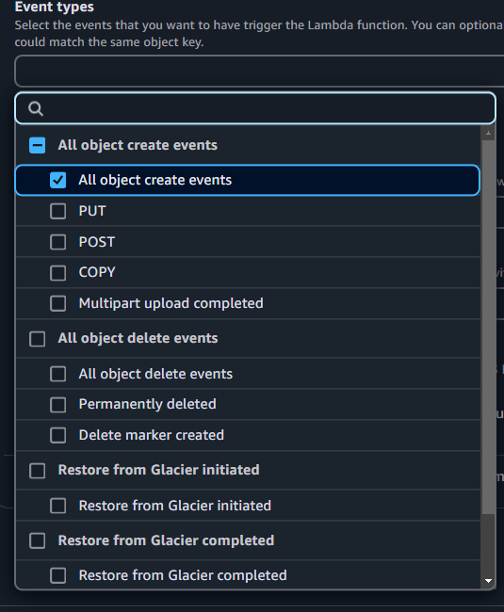

Configure the Event type(On what event inside the bucket you need the task to start) and ADD Trigger

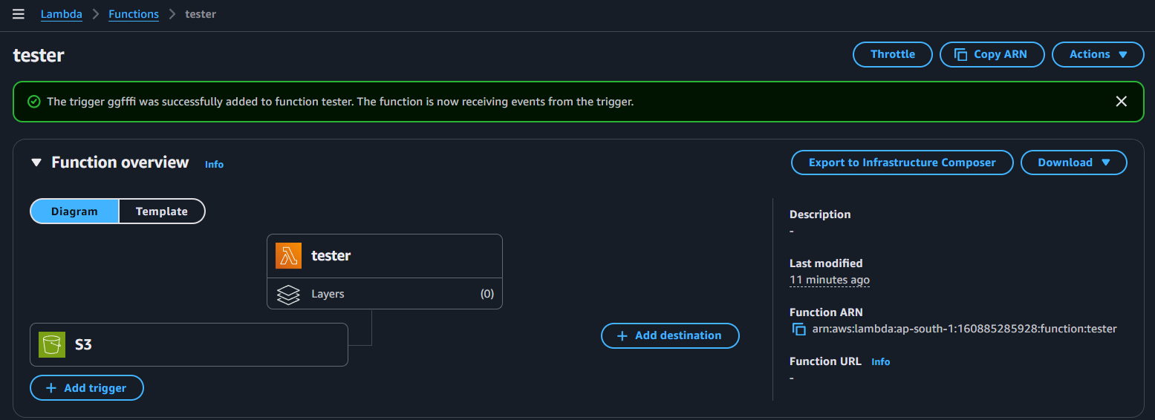

Trigger Added

**ADDING Destination :-**

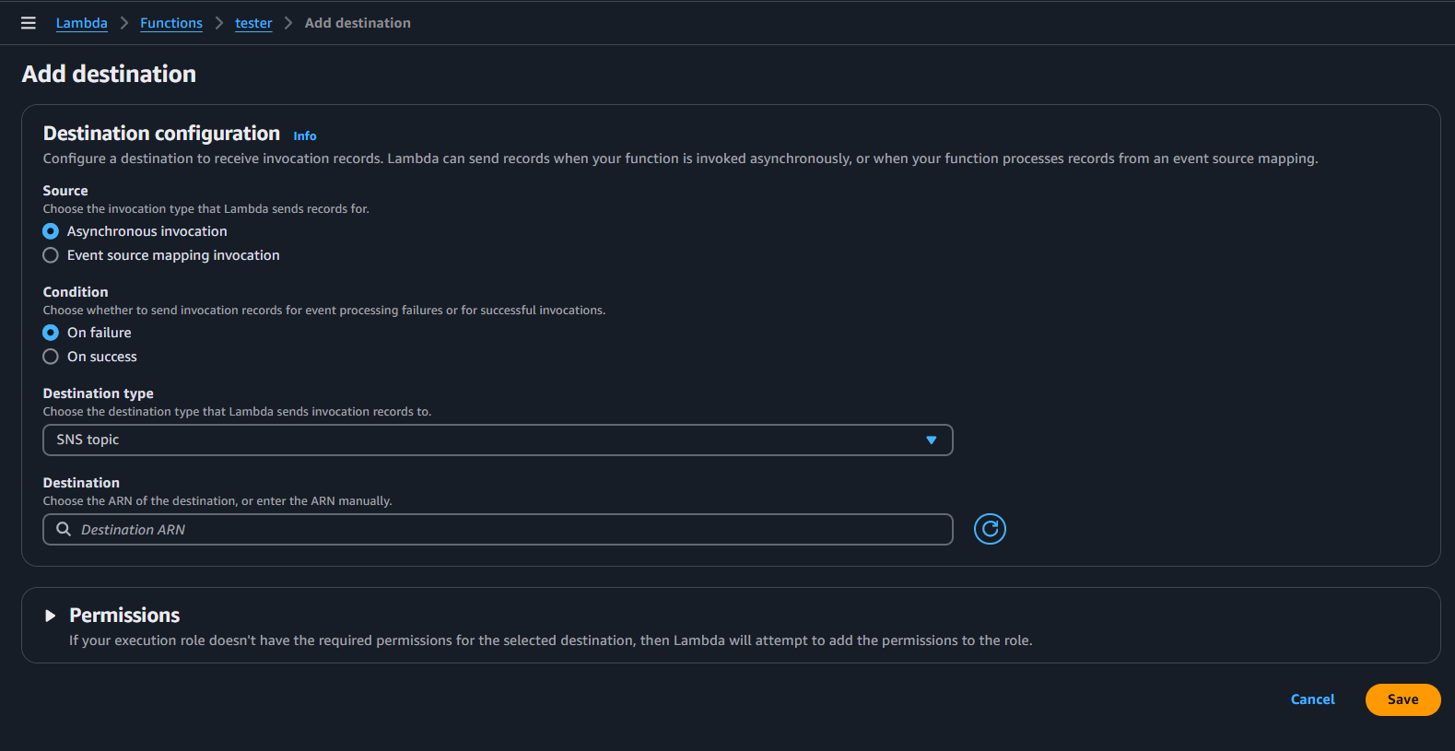

Select Add destination and configure the following

**CASE 1: Adding Success Condition so it will Alert me via SNS topic**

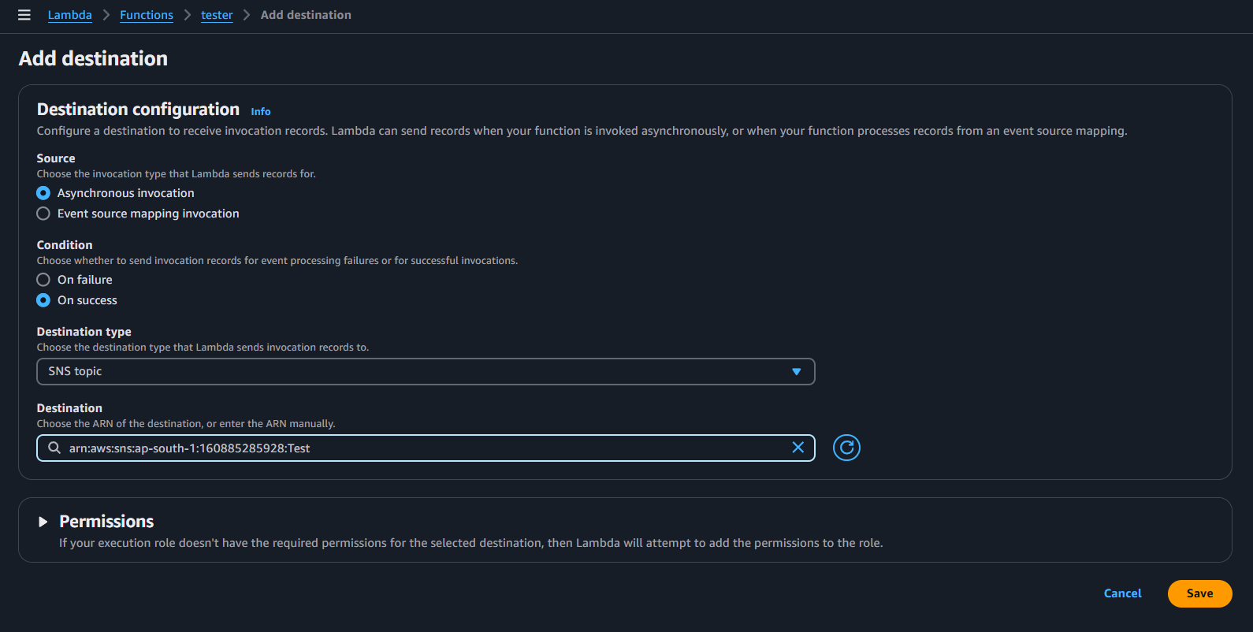

Added Success Condition selected SNS Topic

1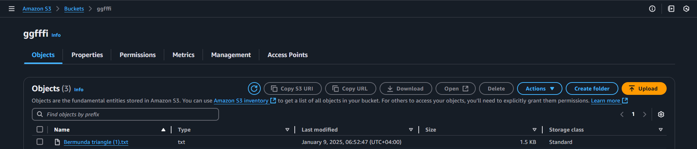

(Target Trigger)In this case; uploaded a object inside the bucket and observed if my lambda function is taking my request properly

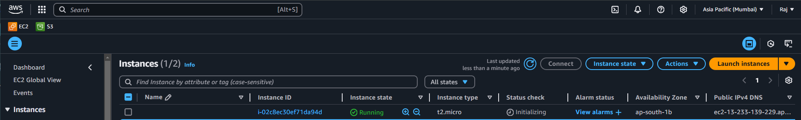

Result :- Hence, it deployed the server (result of the lambda code what I had typed)

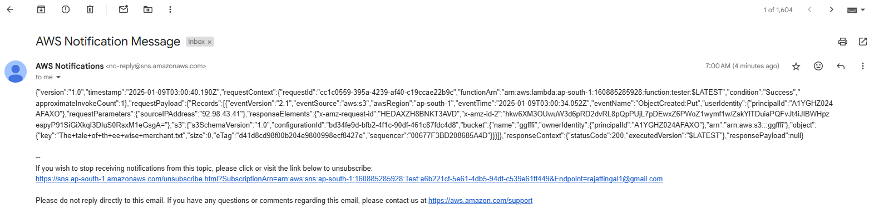

(Destination trigger) My SNS Topic Notified me about the Activity

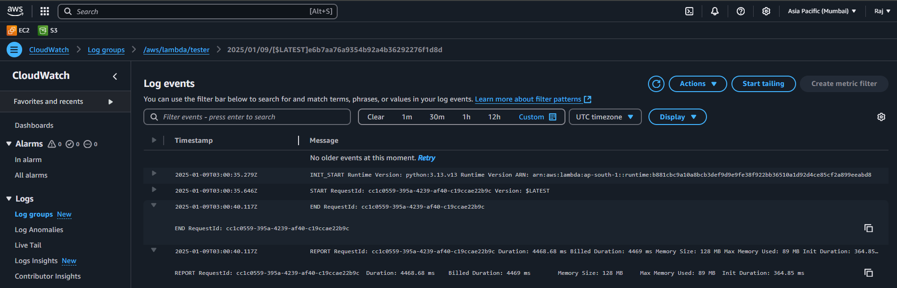

Can check the Logs in Cloudwatch under the aws/lambda logs

**AMAZON EVENT BRIDGE**

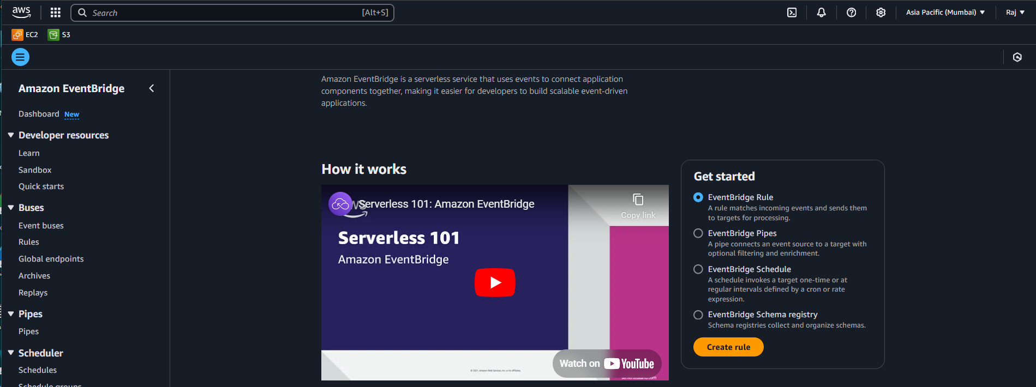

Go to Amazon Event Bridge Dashboard

Creating a Event based Scheduled Rule :-

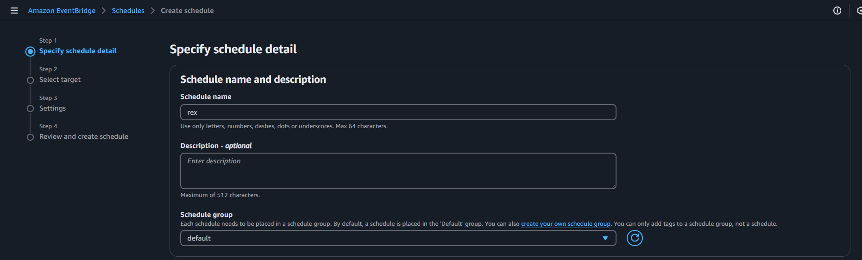

Give name to your Schedule

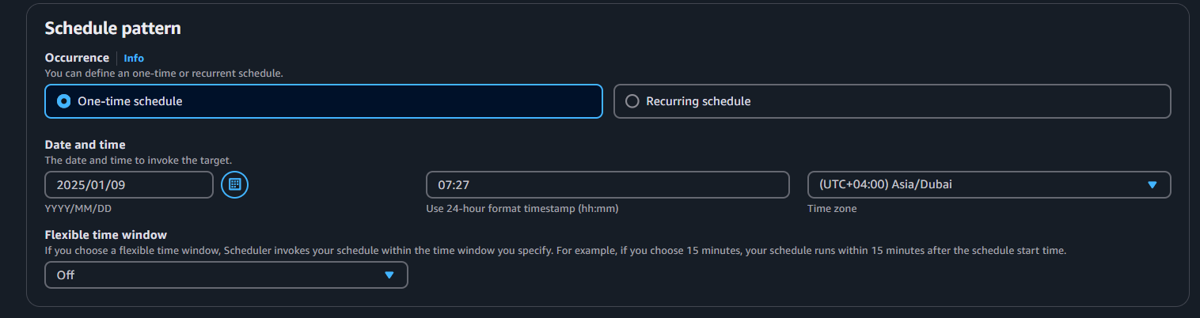

Selected One-Time schedule and gave one particular date and time as (09/01/2025 07:27)

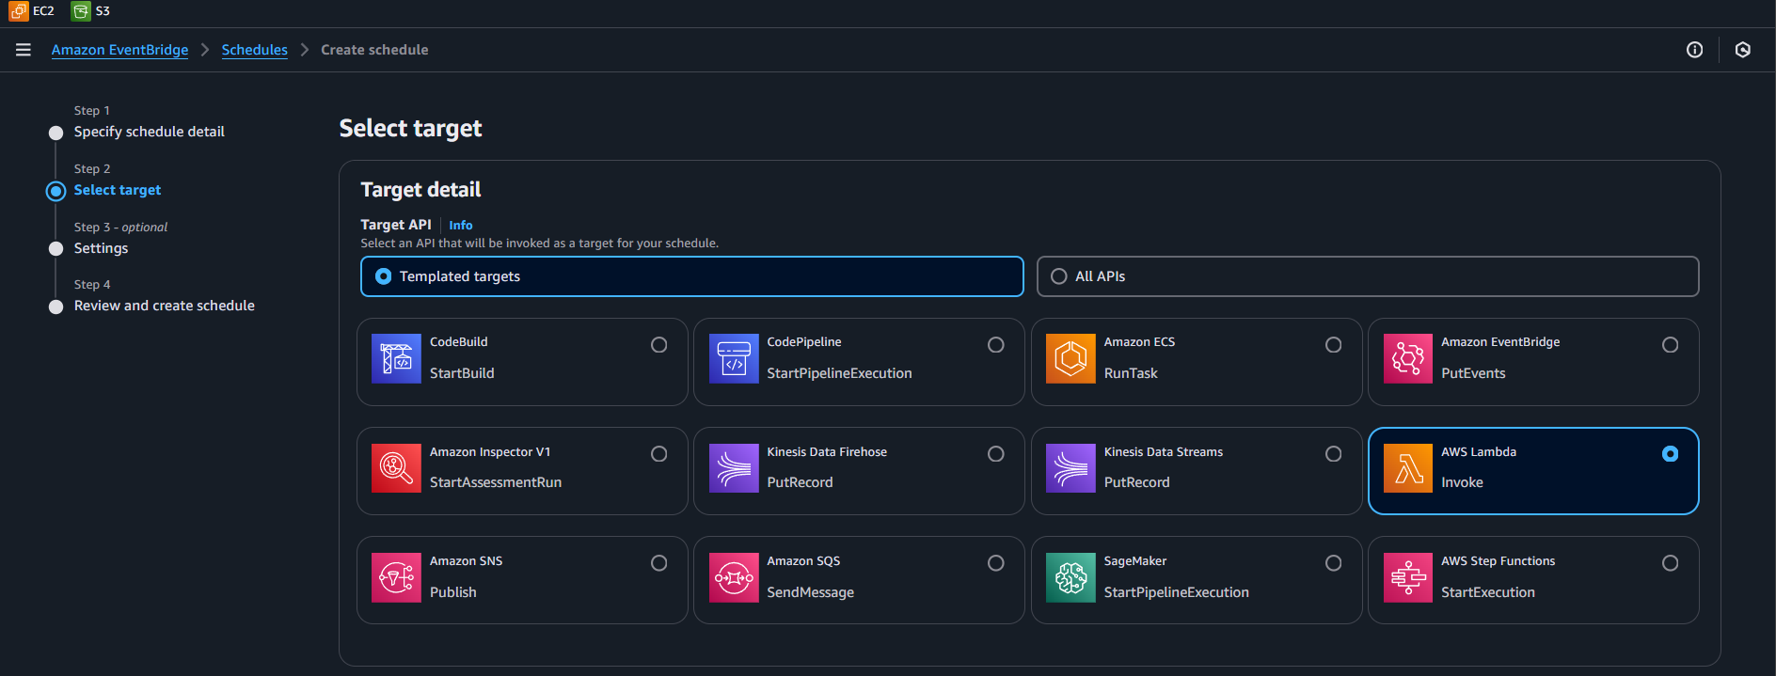

Selected Target as Lambda

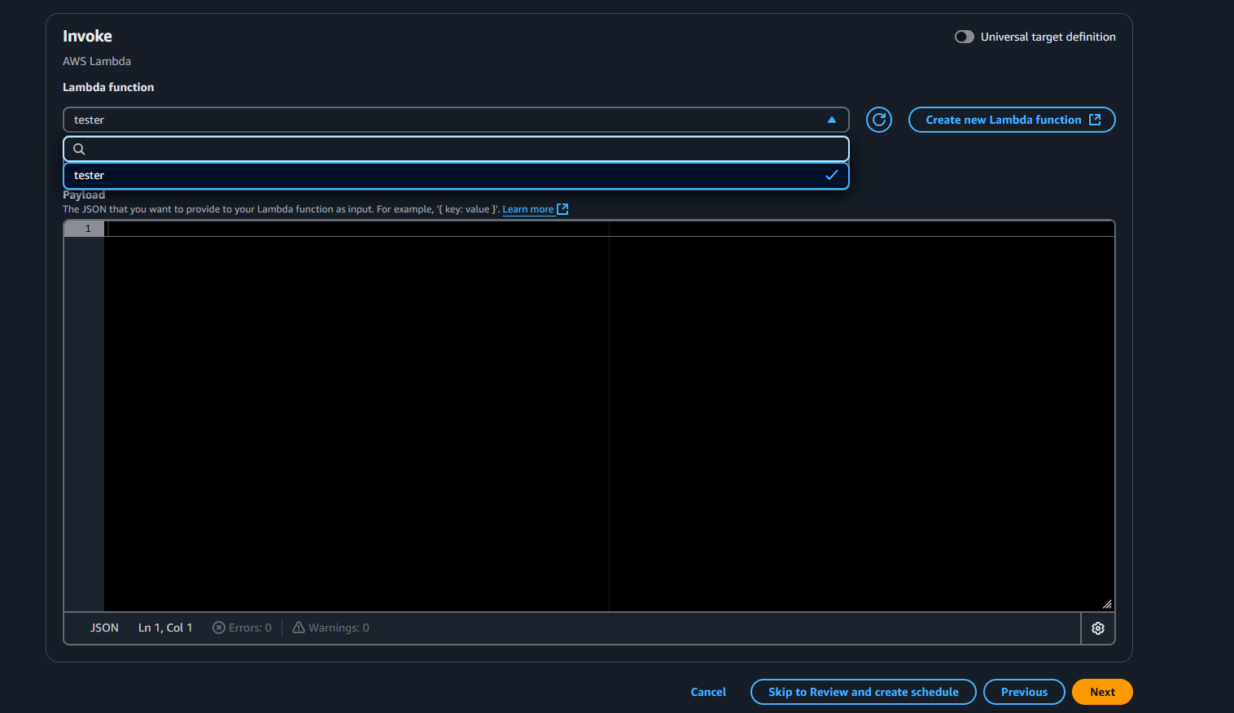

Selected the Lambda Function created TESTER

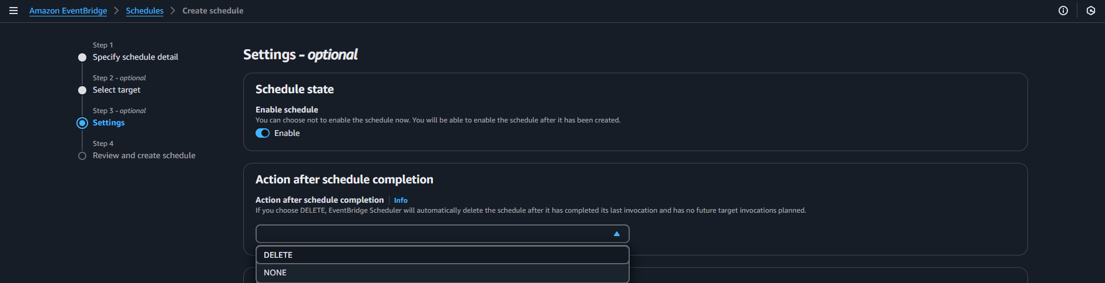

Selected Delete as Action after completion

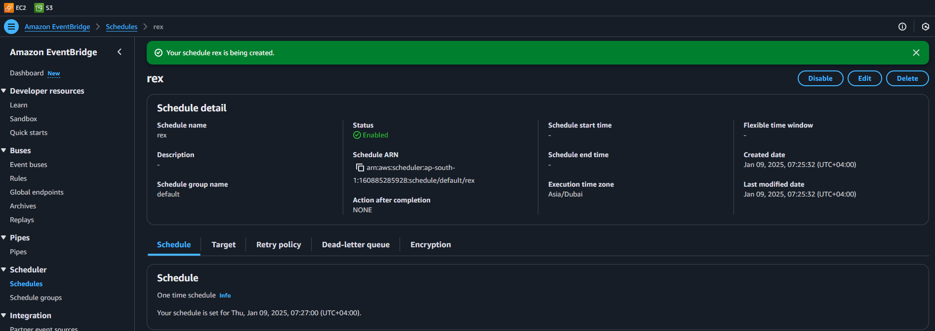

And then Created Rule

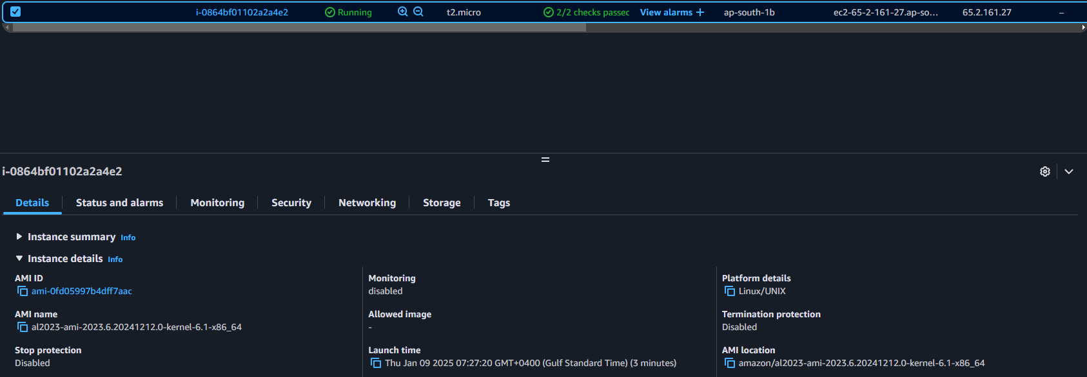

Result : Lambda Triggered via Amazon event Bridge and Launched instance at the given time and date